# Introducing new feature for travelers

Document version: 0.1

Author: Gopalapriya Das

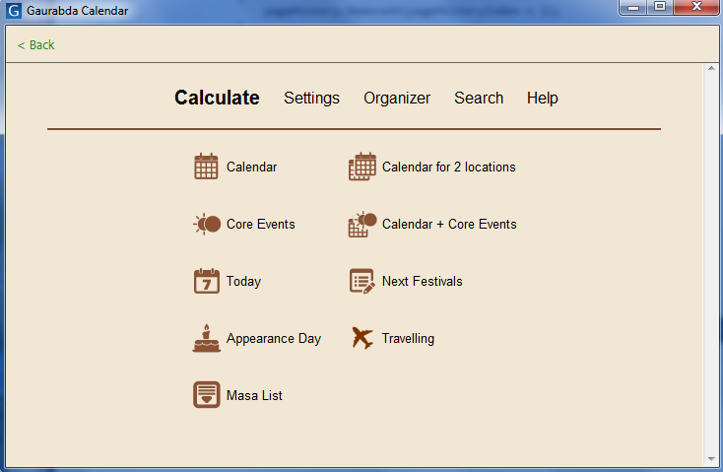

As I am working on new version of GCAL (version 13), I am considering to add one new functionality reserved for those persons, who are travelling and thus sometimes coming to various situations including:

* two consecutive Ekadasi (or any festival or fasting) days
* missing Ekadasi (or any festival or fasting) day

So I produced this paper for your consideration and decision, whether to include this feature in new version or not. It is possible to say, that this could be controversary tool or more confusing, but still, it is a tool. No one is forced to use it.

**An example can be given as follows:**

Person travels from location A (Bali, Indonesia) to location B (Melbourne, AU) on January 30, at 7:00 PM. Flight is 2 hours long so airplane lands in Melbourne on January 31 at 1:00 AM (after midnight).

Problem is, that in Bali, there is Ekadasi fast on January 31, in Melbourne is January 30.

Question: Did that person missed one Ekadasi.

## How to resolve these issues?

Or better question: How to join two calendars for two different locations?

Here I want to present one theory which is based on the fact that Pancanga calendar is calculated according time and location.

In normal situation (person is not travelling) we have two parameters:

1. time ... this is flowing by constant speed
2. location ... this is constant and not changing

Based on these two values, we calculate all astronomical values and then we apply rules for vaisnava calendar and thus we get want we need – a vaisnava calendar.

In travelling situation (person is travelling from location A to location B) we have the same two parameters but with little different dependencies

1. time ... this is flowing by constant speed
2. location ... this is now function of time and therefore may be changing

So my theory is: let’s calculate all astronomical values according time and changing location and then let’s apply rules for vaisnava calendar as in the first situation.

The fact is, that travelling person experiences his/her own succession of arunodaya / sunrise times. So I got an idea, what if we use that specific succesion of astronomical data and use it to generate calendar specific for given travelling schedule.

## Practical example:

|  |  |
| --- | --- |
| Starting location | Delhi, India 28N36 77E12 |
| Destination location | Sydney, Australia 33S52 151E12 |
| Start date | Feb 1 |
| Start time | 2:00 AM (time zone Asia/Calcutta) |
| Flight duration | 8 hours |
| End time | 10:00 AM (Asia Calcutta)  Or 2:30 PM (Australia/Sydney) |
| Sunrise in Delhi | 7:10 AM (time zone Asia/Calcutta +5:30) |
| Sunrise in Sydney | 6:16 AM (time zone Australia/Sydney +10:00) |
| Arunodaya observed by traveler | 3:59 AM (time zone Asia/Calcutta) |
| Sunrise observed by traveler | 4:52 AM (time zone Asia/Calcutta) |

## Consequences

Normally arunodaya is 96 min before sunrise, but when person is changing locations during these times then there is different time between arunodaya and sunrise. Above example shows that from arunodaya to sunrise is 53 minutes.

## Current Limitations

Our vaisnava calendar is sensitive to exact timing of sunrise and arunodaya, so to provide exact and accurate flight data is critical.

Real airplane is not going by constant speed always. In first minutes there is acceleration, then more-less conastct speed and just before landing airplane deccelerates.

Real airplane is flying in altitude 10 – 15 km above the level of sea. Our GCAL calculates sunrise time for altitude 0 m above the sea. That makes different times for sunrise.

# Some examples

For example 1 and 2 there is situation, that in Bali is Ekadasi fast on January 31 and in Melbourne is Ekadasi fast on January 30. So person travelling at midnight from Bali to Melbourne will miss Ekadasi and person travelling from Melbourne to Bali will have two Ekadasis.

But with applying above mentioned “travelling theory” we can resolve these dilemmas.

## Example one – Missing Ekadasi

|  |  |
| --- | --- |
| Starting location | Bali Indonesia |
| Destination location | Melbourne Australia |
| Start date | January 30 |
| Start time | 7:00 PM (timezone Asia/Jakarta) |
| Flight duration | 2 hours |

### Output from GCAL

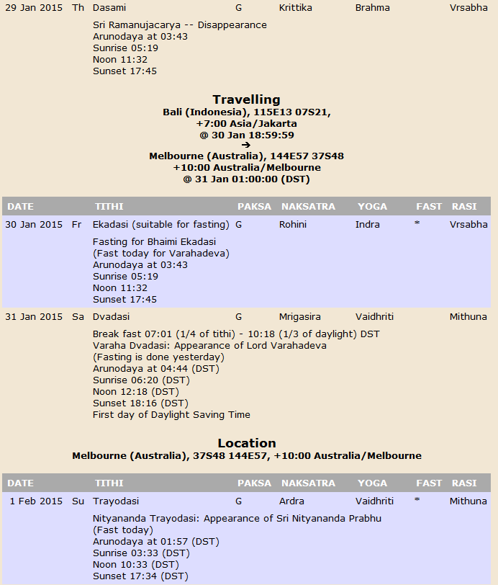

|  |  |  |  |  |  |  |  |
| --- | --- | --- | --- | --- | --- | --- | --- |
|  |  |  |  |  |  |  |  |
|  |  |  | | | | | |

## Example 2 – Two Ekadasis

Similar to previous example, but with the opposite direction (from Melbourne to Bali)

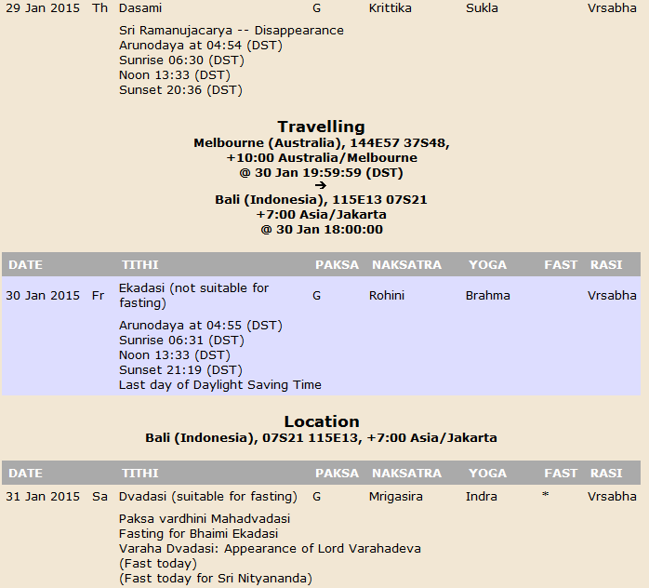

## Open questions

Interesting situation is, that in above example we *deal with Paksa vardhini Mahadvadasi*, Which means if next full or new moon is vriddhi, then Dvadasi is Paksa Vardhini Mahadvadasi.

So we are looking into calendar 4-5 days ahead.

Interesting is, that if travelling occurs whenever between Ekadasi and Purnima, then we still apply this rule for Mahadvadasi and that can lead to situation that everyone else (who is not travelling) is not fasting, but person who is travelling is fasting.

## Example 3 – inconsistent fasting for travelers / non-travelers:

|  |  |
| --- | --- |
| Starting location | Bali Indonesia |
| Destination location | Melbourne Australia |
| Start date | February 1 |
| Start time | 7:00 PM (timezone Asia/Jakarta) |
| Flight duration | 2 hours |

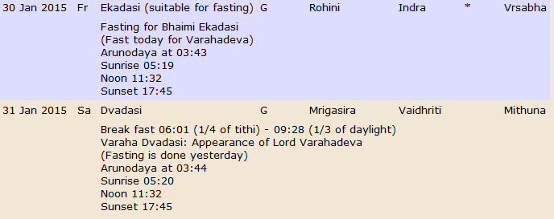

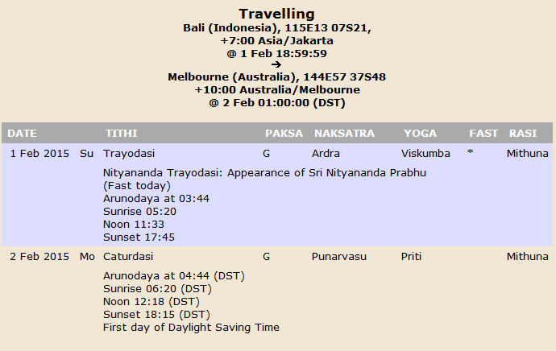

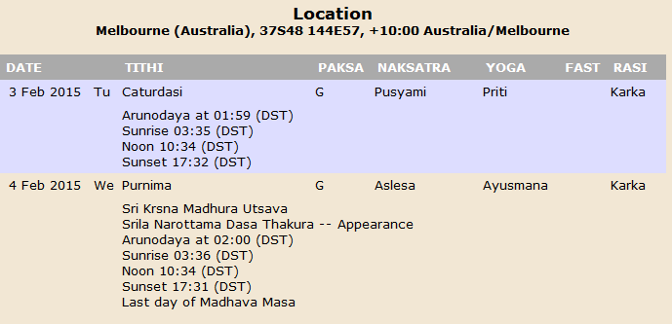

As can be seen in screenshots, Ekadasi fast is calculated for January 30, although everyone else on Bali will fast on January 31. And on January 31, everyone will be fasting, but person who travels will break fast and can happily eat grains on January 31. (I am using kind of extreme language, but that could be interpretation). This is the only pitfall I found in this approach. It relates only to Paksa Vardhini Mahadvadasi because Paksa Vardhini Mahadvadasi is like accounting with the future (4-5 days).

## Conclusion

Please share your thoughts.

We can enable this function in new GCAL with some notice or warning, that what is happening and that it has sense to use the tool only for really confusing situations (travelling just on days on festival or Ekafasi).